Possible solutions to minimize the toxicity in the League of Legends community

A large number of League of Legends players cite toxic environment as their most reason for leaving the

game. Many gaming communities think that toxic behavior as a natural component of online game play.

Theory of Planned Behavior ([Ajzen, 1991](https://www.frontiersin.org/articles/10.3389/fpsyg.2020.598947/full#B2)) argues that an individual’s intentions to engage in toxic

behavior is based on the specific context of the situation. That is, people may behave negatively toward

others if it is accepted as a group norm (i.e., in toxic gamer cultures) and if those who perpetuate toxic

behavior do not experience consequences for their actions.

Toxic behaviors such as bullying, hate speech, cheating and sabotaging are no doubt common in the

League of Legend.

A 2019 report from the ADL reported that 74% of adults who play online multiplayer games in the US

experience some form of harassment while online. [Cary et al. (2020)](https://www.frontiersin.org/articles/10.3389/fpsyg.2020.598947/full#B9) found over half of their surveyed

players (53%) said they experienced harassment because of their race/ethnicity, religion, ability, gender

or sexual orientation and 65% had experienced some form of severe harassment, including physical

threats, stalking, and sustained harassment.

But, allowing these behavior run loose can rapidly lead to a loss of game players and

a corruption of your game culture.

Three suggestions to minimize toxic environment in the game League of Legend.

1. **Share the resources within the team.**

One of the reasons that the players involve with toxic behavior is because the game system is designed that the players in a team compete for resources (Gold, Kills, mobs) within the team. To change this, players could instead share the gold evenly within the team when someone gets the kill. This would decrease anger of the players when their kill has taken by another player.

This possible solution can increase teamwork and it also led to new strategies in the game. Sharing gold withing the team would not affect the game; it would only affect the strategies and tactics in the game.

|  |  |  |  |
| --- | --- | --- | --- |
| **Time of Message:** | **Champion:** | **Message:** | **Meaning:** |
| 12:50 (12 minutes and 50 seconds) | Teemo | Thx for the kills | Teemo could get the kills but another champion call Warwick gets the kills so Teemo is behaving sarcastic to Warwick. |
| 12:52 (12 minutes and 52 seconds) | Teemo | Lane stealin jerk | Teemo thinks Warwick steal his kills so, Teemo take this as the Warwick Stealing his lane possession. And swearing at Warwick. |
| 12:55 (12 minutes and 55 seconds) | Warwick | Watch and learn | Stop complaining about the kills and shut up. |

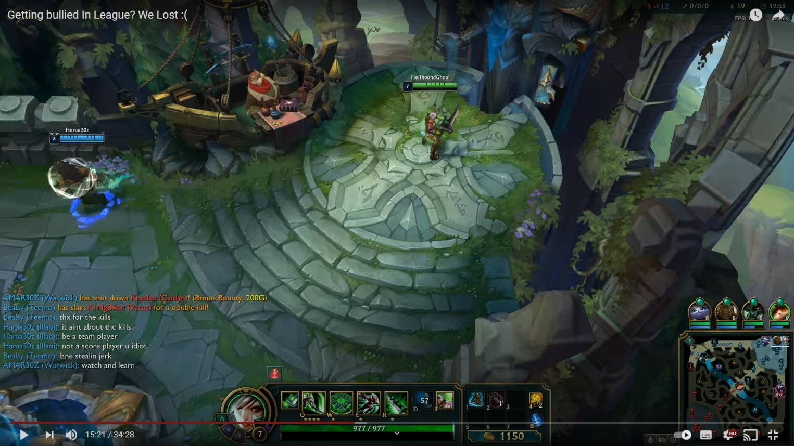

Figure 1. Example of toxic behavior caused by stealing kills and lane.

1. **Rebuilding the game entry and exit system.**

Long length of the match (average game play time is 35 minutes) and not having the ability to exit the game affects how likely they are to engage in toxic behaviors, adding a feature that let players decide when to leave or having the ability join a game where someone left could reduce toxicity. If making players jump in and out of games would interfere too much with the flow of the game, having the ability to kick only players that has been away from the keyboard for a set number of minutes, and having a new player join to take their place, might lessen the feeling of wasting time but it would also decrease the devotion towards each game. This affect players in many ways. The positive side of the change would be the decrease of toxicity, but it would also bring players to become less competitive.

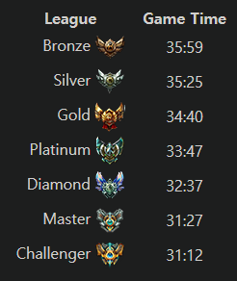

Figure 2. Average game play time ordered by rank.

1. **Provide more incentives to Honor system.**

One of the methods Riot Games have used earlier is the Honor System, which makes players able to give a judgement of a player. The player cannot give himself or herself the honor. This is a nice idea to change player behaviors to become more friendly and supportive, but it is used very poorly in the game, since the only reward is giving the player a visible badge on the side of their Champion before a match starts. But this could be used as a resource to buy game content. This would make the badges to serve a function people want, since they are given a reward for their good behaviors and give players more of an incentive to strive towards collecting them. Since all players are aware there are a lot to learn when playing League of Legends and that a lot of their new players start playing because they have a friend that can mentor them, having a mentorship for new players forum would help new players a lot.

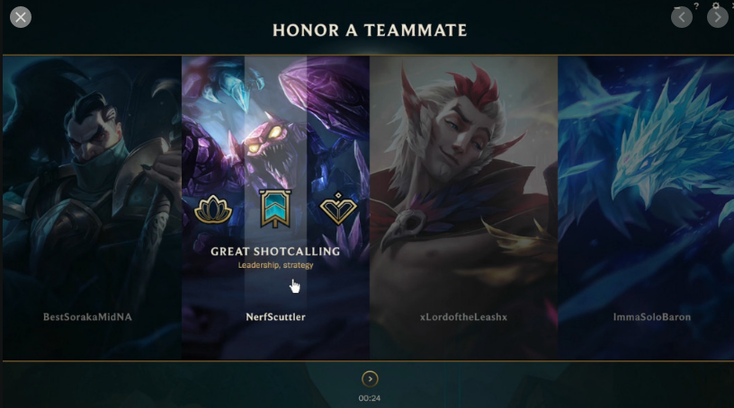

Figure 3. Honor system.

**References**

Ajzen, I. (1991). The theory of planned behavior. *Organ. Behav. Hum. Decis. Process.* 50, 179–211.

Cary, L. A., Axt, J., and Chasteen, A. L. (2020). The interplay of individual differences, norms, and group identification in predicting prejudiced behavior in online video game interactions. *J. Appl. Soc. Psychol.* 1–15. doi: 10.1111/jasp.12700